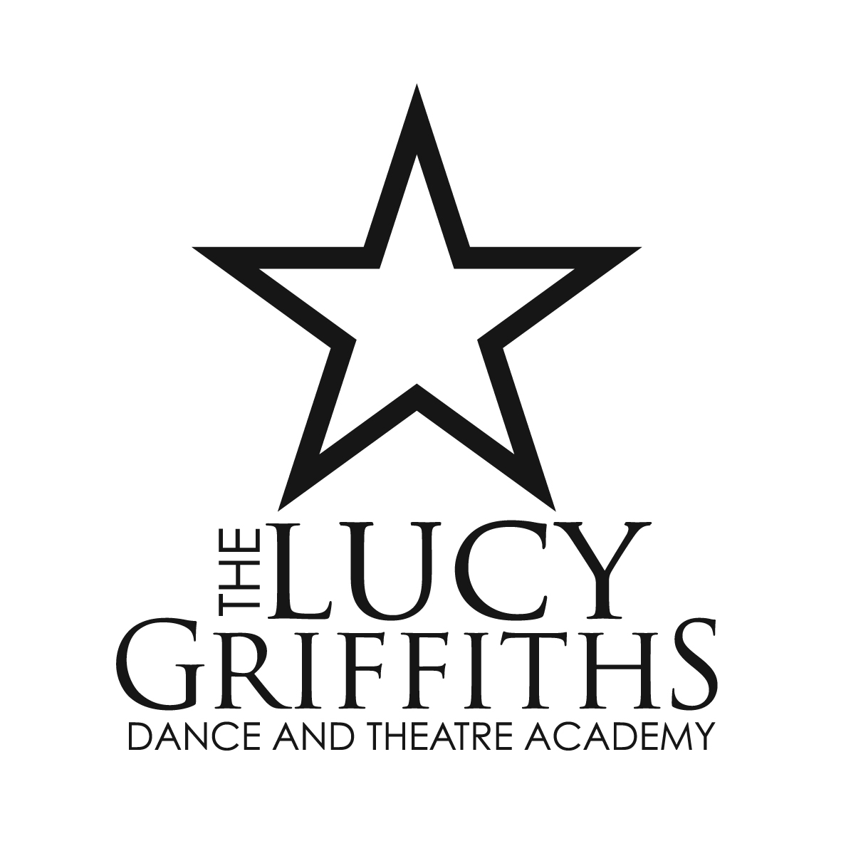
Lucy Griffiths Dance & Theatre Academy Ltd

89 Stapleton Road
Orpington
Kent BR6 9TQ

T: 01689 827 669
E: lucy@lucygriffiths.co.uk
W: www.lucygriffths.co.uk
Company registration no: 8102930 Registered in England & Wales

ACROBATIC ARTS CONCENTRATED ONE DAY COURSE

For Children who already study Acrobatic Arts

by Invitation Only

Warren Road Primary School, Warren Road, Orpington, Kent BR6 6JF

Monday 6 August 2018

We will be holding a one-day Acrobatic Arts Course for our children that have attended the Acrobatic Arts lessons this term. The course will include work on cartwheels, somersaults, handstands, bridge, walk overs, forward rolls and for more experienced tumblers backward rolls, bridge and kick over, bridge prances, handstand walking, the introduction of Arabian handstands, back flicks, forward and backward walk overs and aerials to name just some of the activities that we will be covering on this intensive day!
We will also be introducing Acro Group and Partner work and Acro Choreography.
9.30am – 3.00pm 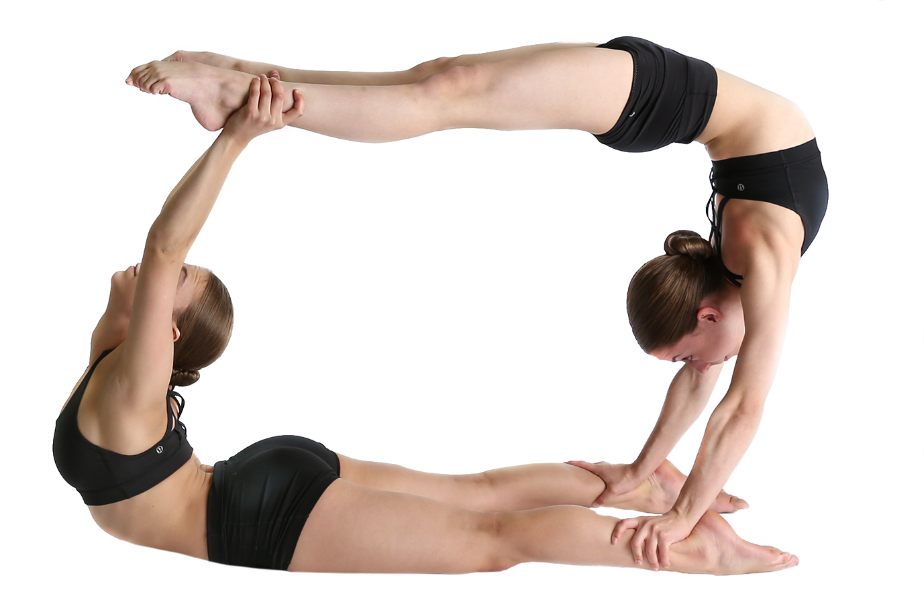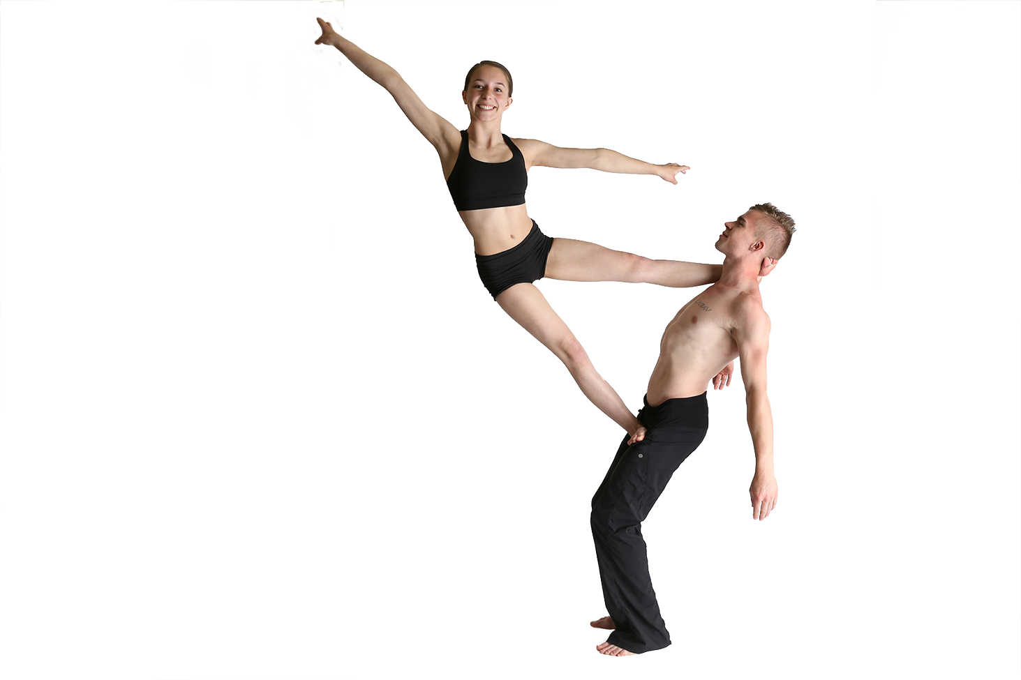
Cost £30.00 includes VAT 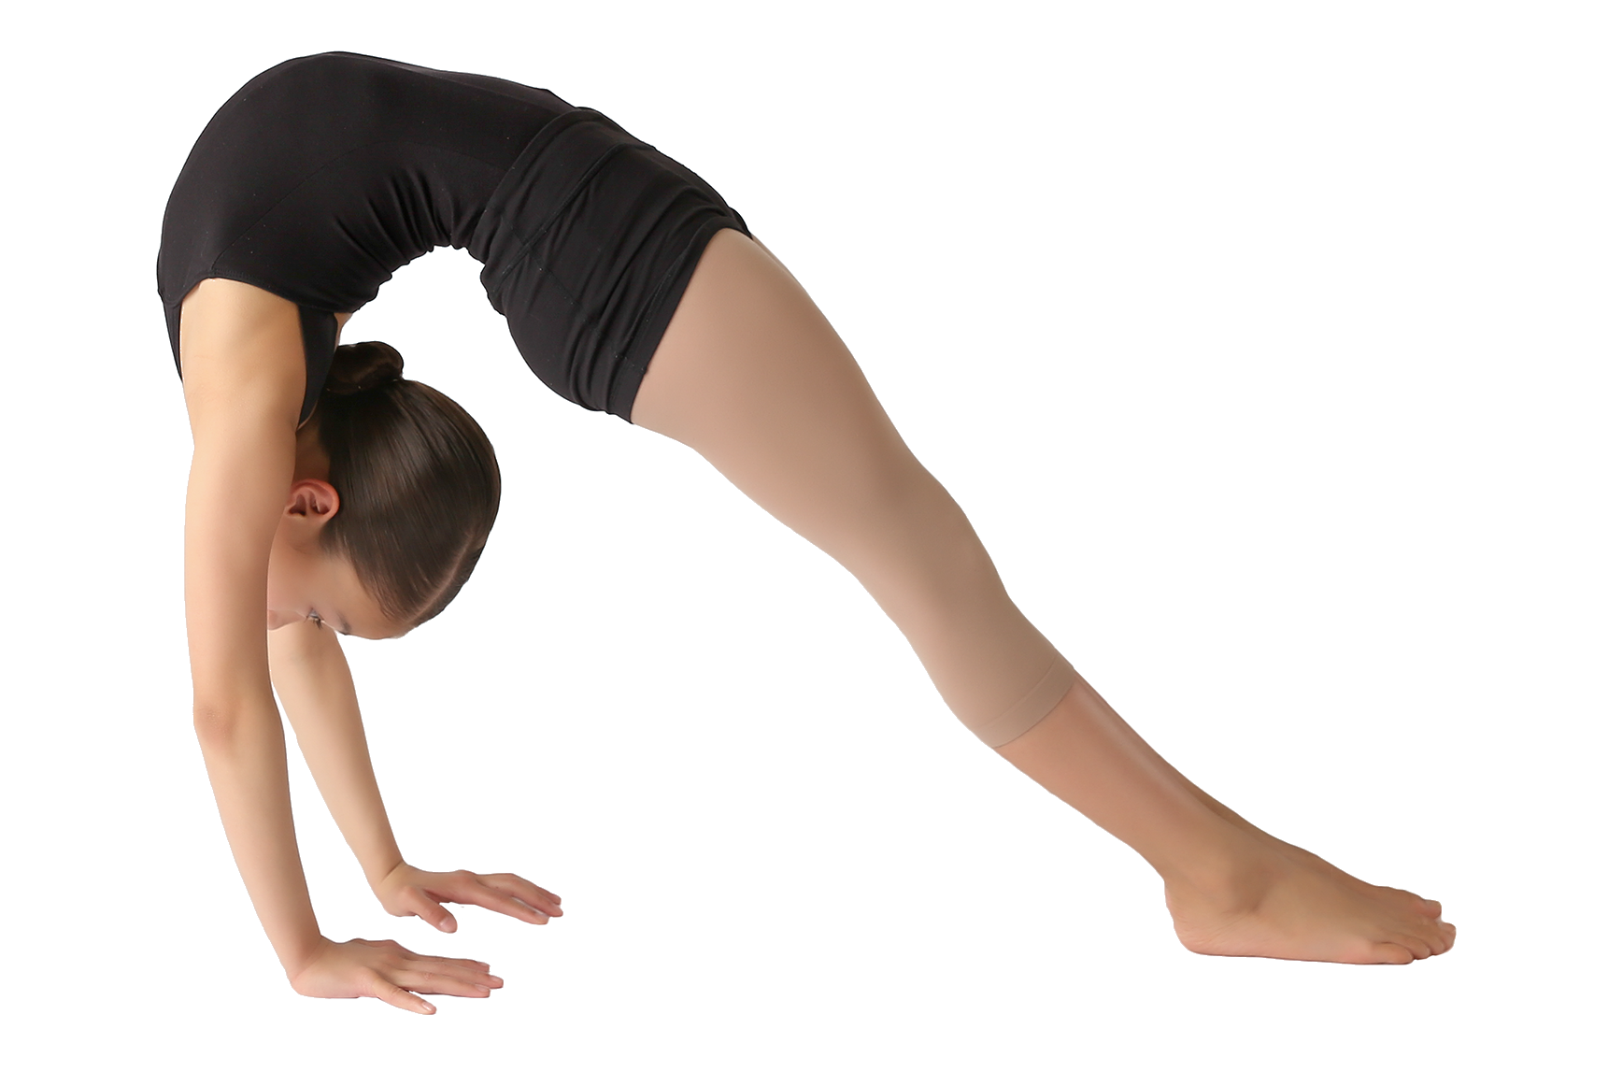
If paid in full by Sunday 8 July, the discounted rate will be £25.00 includes VAT

If you had already book your child on the half day course, please contact the office to confirm which course you would like your child to take and make payment for the difference if they will be now taking the one-day course.

All course fees non-refundable
ALL COURSES
Snacks & drinks will be provided at break times for all days.
Please bring packed lunch on the course.
Teachers DBS checked, fully qualified & First Aid trained.
Please wear dancewear suitable for Acrobatic Arts with bare feet.



ACROBATIC ARTS CONCENTRATED ONE DAY COURSE

BOOKING FORM

Pupil Name:

Age:

Date of Birth:

Parents Name:

Mobile:

Email:

My child has the following allergy, medical condition, disability or special requirement:

I give permission that photographic and video footage may be taken during the summer courses. I also give permission that these materials may be used for advertising and promotion purposes for the Academy. YES/NO
Acrobatic Arts Course
One-day Course £30.00
If paid in full by Sunday 8 July £25.00
Total Paid £
Bank Transfer Date:
SANTANDER
Lucy Griffiths Dance & Theatre Academy Ltd
Account No: 29909325
Sort Code: 09 01 28
Please use your child’s full name as the reference.

WWW.LUCYGRIFFITHS.CO.UK

Email: lucy@lucygriffiths.co.uk
Office: 01689 827669

